W-20
YEAR 10 SCIENCE
BIOLOGICAL SCIENCES
REVISION

1. Label the following simple cell drawing.

Nucleus Ribosome Mitochondria Rough Endoplasmic Reticulum Golgi Apparatus Nucleolus Cytoplasm Centrioles

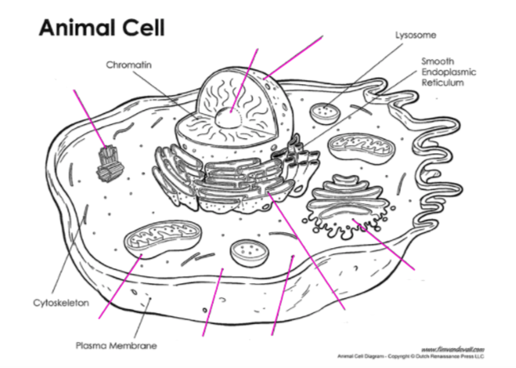

2. (a) Where in the cell do you find DNA?

(b) Describe the shape of the DNA molecule.

(b) Name the 4 bases in a DNA molecule.

• G • A • T • C

(b) Which bases are paired together in DNA?

(c) Draw the adjoining strand of DNA for the following.

- G - T - T - A - C - A - G - T

3. (a) Which process of cell division is responsible for the growth and repair of cells?

(b) Which process is involved in producing the reproductive cells of an animal?

4. Define the following terms.

allele
pure-bred
hybrid
homozygous
heterozygous
genotype
phenotype
dominant
recessive
haploid
gene
incomplete dominance
co-dominance

5. Below is a diagram showing the mitosis cell division process. The stages are in the wrong order. Try to put them in the correct order in the blank diagram.

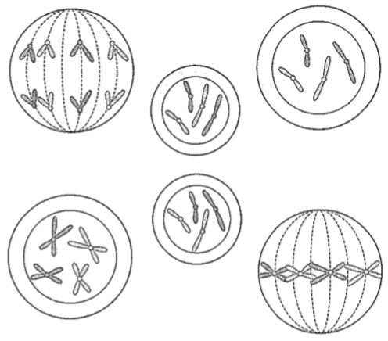

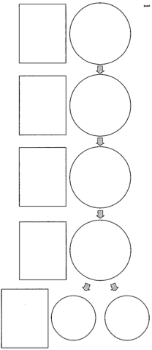

6. (a) What are the genes (genotype) for the male and female sex chromosome pair?

(b) Who determines the sex of a child - the mother or father? Explain.

(c) A family has had five girls born into it, and the mother is pregnant with the sixth child.
What is the chance that the child will be a girl?

7. In humans, the ability to taste a chemical phenylthiocarbamide (PTU) is due to the presence of the dominant gene T.

(a) Determine the genotype and phenotypes of the offspring produced by the marriage of a
homozygous non-taster male (tt) and a heterozygous taster female (Tt). Set your working out.

(b) Study the pedigree chart below showing the occurrence of tasters in a family. A shaded square or circle represents a taster.

2
1
(i) How many males are non-tasters?

(ii) How many females are tasters?

(iii) How many children did parents 1 and 2 have?

(iv) How many of their children are non-tasters?

(v) Try to write the genotype (actual genes) for each individual in the pedigree. Remember to work from the bottom up.

8. The pedigree below shows the existence of straight hair in a family.

Is straight hair a dominant or recessive trait? Explain your answer. You may need to circle part of the pedigree to help explain.

